JOIN THE 2015 IJPC ASSOCIATES
INDIVIDUAL MEMBERSHIP: $50
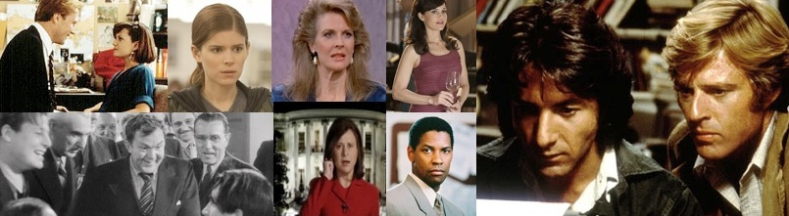
Special AEJMC Member Discount Membership: $35

IJPC ASSOCIATES WILL HAVE COMPLETE ACCESS TO:
THE HEROES AND SCOUNDRELS JOURNALIST IN POPULAR CULTURE PROJECT
IT’S A BOOK - IT’S A VIDEO – IT’S A WEBSITE – IT’S A CLASS – AND SO MUCH MORE

THE BOOK:
Heroes and Scoundrels: The Image of the Journalist in Popular Culture
By Matthew C. Ehrlich, professor of journalism at the University of Illinois at Urbana-Champaign, and Joe Saltzman, professor of journalism and communication at the University of Southern California, published by the University of Illinois Press, 2015.

THE WEB SITE:
The Heroes and Scoundrels Web site continuously updates and adds supplementary material to the book. It includes original and reprinted articles, visuals and links to special materials for each chapter: History, Professionalism, Difference, Power, Image, War and The Future. It is available at www.ijpc.org -- Heroes and Scoundrels. The Heroes and Scoundrels Web site is an invaluable addition to the book for students, teachers, journalists and researchers. It is updated weekly and anyone can e-mail the authors for more information and clarification.

THE VIDEO:
The 40-hour video companion to the book, written and produced by the authors, follows the outline of the book and is divided by the same chapters using on-screen writing from the book and voice-over for excerpts from more than 350 movies, television and radio programs, Broadway plays and video games. More than 8,000 hours of video were edited down to the 40-hour final video project, which summarizes through visual and audio excerpts the examples used in the book. Only members of the IJPC Associates will be legally allowed to receive the video package for personal and educational use only. It is available on mp4 files stored on a 1TB Hard Drive.

THE CLASS:
The Heroes and Scoundrels Project offers you everything needed to create the perfect IJPC class.
*There is the book itself, which brings the IJPC into the field of journalism studies – Heroes and Scoundrels: The Image of the Journalist in Popular Culture” by Matthew C. Ehrlich and Joe Saltzman. The introduction, six chapters, and the conclusion create an automatic semester-long outline for you. A syllabus is available upon demand.
*There is the Heroes and Scoundrels Web site, which constantly updates and adds valuable materials on the subject.
*There is the 40-hour video project that is broken down chapter by chapter for easy viewing outside of class (you can also show the excerpts you want to emphasize in class).
*Homework is ready-made – the chapter out of the book, the video component and the Web site provide innumerable potential assignment ideas.

For more information, contact:
Joe Saltzman, Director of the Image of the Journalist in Popular Culture (IJPC)
saltzman@usc.edu. • Web Site: www.ijpc.org • 213-740-3918
IJPC ASSOCIATES MEMBERSHIP APPLICATION FORM
The Image of the Journalist in Popular Culture (IJPC), a Project of the Norman Lear Center
Annenberg School for Communication and Journalism, University of Southern California (www.ijpc.org)
NAME _________________________________________________________________________________________
TITLE _________________________________________________________________________________________
SCHOOL or DEPARTMENT_______________________________________________________________________
INSTITUTION___________________________________________________________________________________
MAILING ADDRESS_____________________________________________________________________________
CITY_________________________________ STATE __________________ ZIP CODE_______________________
BUSINESS PHONE NUMBER______________________________________________________________________
HOME PHONE NUMBER (OPTIONAL)______________________________________________________________
E-MAIL ADDRESS_______________________________________________________________________________
AEJMC SPECIAL INDIVIDUAL MEMBERSHIP ($35-$50)____ INSTITUTIONAL MEMBERSHIP ($150)_______
HEROES AND SCOUNDRELS PACKAGE + IJPC COLLECTIONS ($80 - $100)_____________________________
TOTAL ___________METHOD OF PAYMENT: Check__________ Cash ___________ Credit Car_______________
IF CREDIT CARD: Visa • MasterCard (Circle One)
Name as it appears on Card _________________________________________________________________________
Credit Card Number _____________________________________________ Expiration Date_____________________
Please make checks payable to IJPC USC Annenberg.
As a new IJPC Associate, you will receive complete access to The Heroes and Scoundrels Project:
The book is available on Amazon in hard-cover, paperback, e-book, Kindle and aps for IPads, IPhones and other smart phones.
The video: The complete video program will be available to you on Quicktime Player .mp4 files. We also have purchased a series of 1TB Hard drives for your convenience. Since the 40-hour video package takes up about 250GB, that means you will have 750GB of storage space for your own videos, documents and photographs.
As a bonus, the complete 40-hour IJPC Video Collection (nine videos) will also be included at no additional cost.
But there are several unavoidable costs involved:
* Only members of the IJPC Associates will be legally allowed to receive the video package free of charge. If you are not already a member of the IJPC Associates, with proof of purchase of the book, your annual fee will be reduced from $50 to $35. If you are a member, this cost will not apply.
*The cost of the brand new 1TB Hard drive, complete with the mp4 files of the 40-hour Heroes and Scoundrels video package included, will cost $80.00. This will include shipping and handling costs. That price only covers the cost of the hard drive and shipping/handling. There is no charge for the 40-hour video set. You must specify whether you want the IMac (Apple) or Windows application.

To receive the video package:
E-Mail Application Form to: saltzman@usc.edu
Or send Application Form to: Image of the Journalist in Popular Culture (IJPC) Attention: Joe Saltzman, Room 102B, Annenberg School for Communication and Journalism, University of Southern California, 3502 Watt Way, Los Angeles, CA 90089-0281.
Information: 310-377-8883. Fax: 310-377-7935

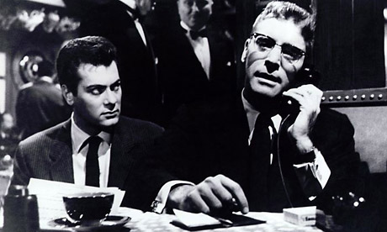
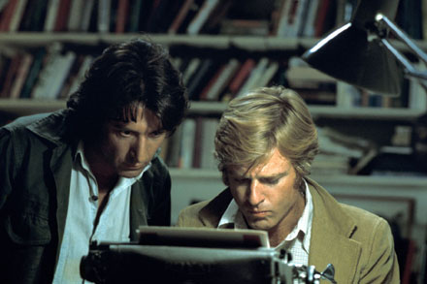
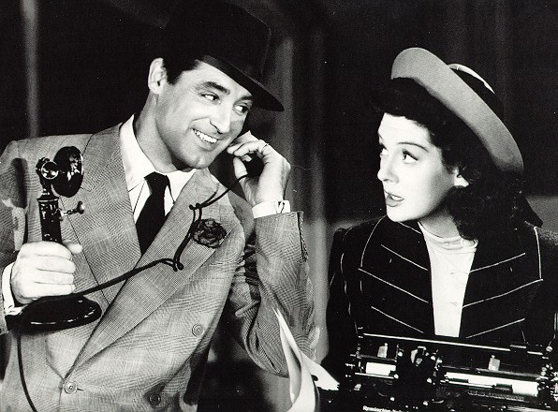
The Image of the Journalist in Popular Culture (IJPC) Database
Is Now AVAILABLE ONLINE AT NO COST
www.ijpc.org

The Image of the Journalist in Popular Culture (IJPC) Online Database©
contains more than 86,000 items on journalists, the news media and public relations practitioners
in films, television, novels, cartoons, commercials and other aspects of popular culture:

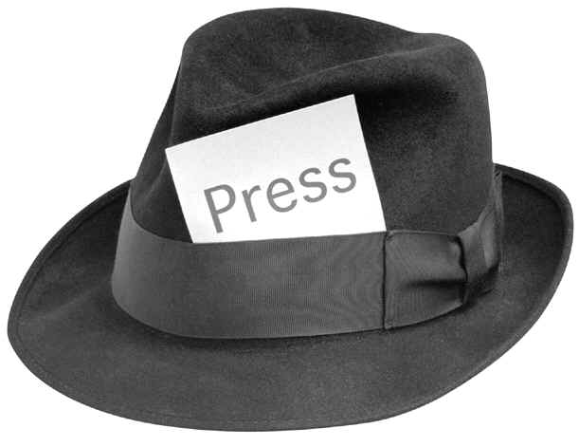
● Television (33,020 items)
● Films (20,315 movies, movies made for TV and miniseries)
● Fiction (14,197 novels, 1,731 short stories, 598 plays and 260 poems)
● Cartoons, Comic Books & Comic Strips (6,575 items)
● Non-Fiction (Documentaries-News-Sports) (3,274 items)
● Radio (4,206 items)
● Humor (750 items)
● Commercials (462 items)
● Games (188 items)
● Music (Songs-Compositions) (135 items)
● Early References (120 items)
● Internet-Websites (104 items)
● Art (45 items)
The IJPC Database includes print journalists (from large urban newspapers to small country weeklies, from magazines to the Internet, including editors, reporters, photojournalists, correspondents, columnists, publishers, newsboys), broadcast journalists (from networks to local stations, including reporters, anchors, producers, correspondents, writers, technical personnel, news directors, station owners, network executives), public relations practitioners (from press agents to publicists), and the news media (anonymous reporters who show up in countless films and television movies ranging from press conferences to packs of reporters shouting questions or chasing after the main character to individual reporters asking questions) to multimedia journalists.

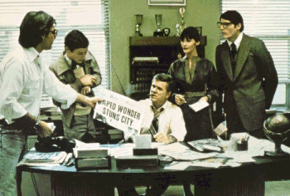

The Image of the Journalist in Popular Culture (IJPC) is a project of the Norman Lear Center at the Annenberg School for Communication and Journalism at the University of Southern California.

The IJPC Journal
http://www.ijpc.org

Volume Five – Fall 2013 – Spring 2014 – Now available Online

An Online Academic Journal
To Further the Mission of
The Image of the Journalist
in Popular Culture Project

To Investigate and Analyze
Through Research and Publication the Conflicting Images of
Journalists in Every Aspect
of Popular Culture

This e-journal is:
- Free
- Online only
- Multimedia
- Interdisciplinary
- Adhering to the highest standards
of peer review

To subscribe to the journal, email updates and submit articles: http://www.ijpc.org

Co-Founding Editors: Matthew C. Ehrlich, University of Illinois at Urbana-Champaign
•Sammye Johnson, Trinity University • Joe Saltzman, University of Southern California

Editorial Board: Maurine H. Beasley, University of Maryland • Bonnie Brennen, Marquette University
• Mary-Lou Galician, Arizona State University • Loren Ghiglione, Northwestern University • Howard Good,
SUNY, New Paltz • Norma Fay Green, Columbia College, Chicago • Richard Ness, Western Illinois University • Radhika Parameswaran, Indiana University • Karen Miller Russell, University of Georgia
• Barbie Zelizer, University of Pennsylvania

Published by USC Annenberg School for Communication & Journalism

